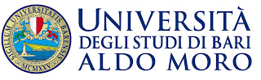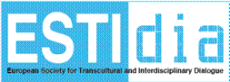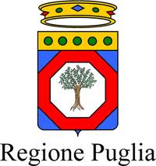

**2nd ESTIDIA Conference 2013**

***Dialogue-driven Change in the Public Sphere***

**Department of Educational Sciences, Psychology, Communication**

**University of Bari “Aldo Moro”**

**4-6 October, 2013**

After its successful launch in Brasov, Romania, in June 2012, **ESTIDIA** (*European Society for Transcultural and Interdisciplinary Dialogue*) is convening its second conference, whose goal is to create a discussion forum bringing together researchers and doctoral students who are investigating change-related dialogue mechanisms and strategies from a wide range of disciplinary perspectives.

The University of Bari, Italy, has the pleasure to host **ESTIDIA 2013**, in the hope that this conference will give rise to creative synergies and facilitate new networks, crossing both geographical and disciplinary borders.

***Conference Theme***

Change, be it subtle or dramatic, is constantly an integral part of social life, bringing about significant alteration of social structure, behavior patterns and cultural values. *Social change* refers to variations over time in the ecological ordering of populations and communities, in patterns of roles and social interactions, in the structure and functioning of institutions, and in the cultures of societies. In recent times, two fallacies about social change have been intensively debated. According to the first fallacy, social change is simply a linear movement in time from a traditional past towards a modern future, while old values and institutions are regarded as impediments to changes and obstacles to modernization. The second fallacy is based on the assumption that there is an irreconcilable conflict between old and new traditions and structures, which leads to old traditions and structures being simply displaced by new ones. However, both fallacies have been proved wrong and consequently discarded by a large body of studies which provide alternative interpretations that challenge the assumptions of the traditional-modern polarisation. In the dynamic and multi-dimensional reality that we experience daily, tradition and modernity are in fact mutually reinforcing, rather than being mutually exclusive systems. It is these two aspects, dialogue-driven continuity in discontinuity, and discontinuity in continuity, that are the topic focus for the conference presentations and discussions.

The various theories of social change range from those that explain specific factors that cause small-scale changes to abstract and broader theories which attempt to understand underlying trends in the evolution and transformation of human societies. The focus of the conference is on the traditions, principles, purposes and practices of dialogic interaction in the public sphere that are part of, and conducive to, societal change. While many societies are currently experiencing dramatic shifts in their political, economic and social structures, there are at least two dominant trends: the increasing democratization of political life, and the rise of complex bureaucratic institutions. The key factors of social change underlying these trends are globalization, technological developments, systemic upheavals, migration and the ensuing multiculturalism and multilingualism. But perhaps the most potentially powerful factors of social change are the people animated by a profound need to communicate and, through public dialogue, to craft a dynamic vision for a more just set of social arrangements in the pursuit of major goals in the service of the common good. The implementation of visionary ideas calls for critically discussing ideas and conceptualizations which take into account the continuously changing nature of societies and communities, and which aim at explicating the interdependence between individuals’ interaction practices and the discursive construction of identities, on the one hand, and their access to full participation in society, on the other.

Key issues of interest to the conference include, but are not limited to, the following:

*- Promoting citizen-centred multicultural and social practices in Europe and beyond*

*- Enhancing the dialogue of tradition and innovation at the interface of the public and private spheres*

*- Initiating and responding to societal changes through cross-European networking activities*

- *Exploring patterns of social and personal change at micro- and macro-level*

*- Scrutinizing dialogic problem-solving strategies in cross-cultural perspectives*

*- Identifying divergence and convergence patterns in public narrative and dialogue*

*- Discourse of social change – Boundary-crossing between practice and theory*

We welcome contributions from diverse fields of enquiry, including discourse studies, conversation analysis, discursive psychology, critical discourse analysis, rhetoric, narrative analysis, political discourse analysis, social semiotics, multimodal discourse analysis, applied linguistics, gesture studies, as well as approaches to dialogue and verbal interaction pertaining to sociology, political science, pedagogy, comparative education, philosophy, anthropology, media studies, journalism and cultural studies. Proposals for individual papers or special sessions may include research questions like the following:

* How should we grapple with the notion that arguing for and against is an opportunity for positive change?
* How can interpersonal and institutional interactions facilitate and encourage bottom-up or top-down social change (in processes of political transition, power transfer and empowerment, business outsourcing, etc.)?
* How are the concrete, daily instantiations of social change articulated in public debate (e.g. media interviews, press conferences, political debates)?
* How can concepts such as identity, migration, community, and citizenship illuminate key aspects of ongoing social, political and cultural change?
* How are the various aspects of social change discussed in the media, in educational institutions, and/or in the political sphere?
* How is understanding social change going to enrich the researchers’ correlation between theory and practice?
* How are messages for and against social change conveyed in public speaking and debating?
* How is the contribution of pedagogy and psychology to be integrated in the debate on social change?

In addition to paper presentation, two thematic workshops are being organized within the framework of the ESTIDIA 2013 conference:

* Workshop on “*Gender Empowerment through Social Innovation Strategies*” (*GENESIS*) – based on a project proposal by a European research consortium consisting of participants from eight EU countries
* Workshop on “*Re-negotiating Identities in the European Public Sphere*” – based on an ongoing research project at SNSPA (National School for Political and Administrative Studies) in Bucharest, Romania

***Abstract Submission***

We invite submissions of abstracts for paper presentations (20 minutes for presentation, to be followed by 10 minutes for questions) to be scheduled in parallel sessions. The abstract should indicate the leading research question, theoretical approach, research methods, data sources, results or expected results, and relevance of the research. Abstracts will be peer-reviewed by the conference scientific committee.

Please include in the abstract: the title of the paper, the name(s) of presenter(s), institutional affiliation and email address.

**Email submission to:** [alberto.fornasari@uniba.it](mailto:alberto.fornasari@uniba.it)

**Conference Website:**  [www.fasf.uniba.it](http://www.fasf.uniba.it) ; [www.uniba.it](http://www.uniba.it)

***Important Dates***

Submission deadline: May 1, 2013

Notification of acceptance: June 1, 2013

Draft papers: July 30, 2013

***Registration fee***

The early bird conference fee is 100 EUR, late registration fee (no later than 5th August 2013) is 120 EUR. The registration fee includes, in addition to the CD-ROM publication of conference proceedings, a conference bag, welcome cocktail, refreshments/coffee breaks and guided visits of Bari.

***Venue***

The 2013 ESTIDIA conference will be hosted by the University of Bari “Aldo Moro”.

University website: [www.uniba.it](http://www.uniba.it) ; [www.fasf.uniba.it](http://www.fasf.uniba.it)

# How to get to Bari

Reaching Bari is not difficult at all: this is possible thanks to the fact that Bari is the provincial capital of the region and for this reason it is one of the major touristic destinations of southern Italy. Bari is also very important for its geographical location which provides connections with northern and central Italy and with foreign countries.

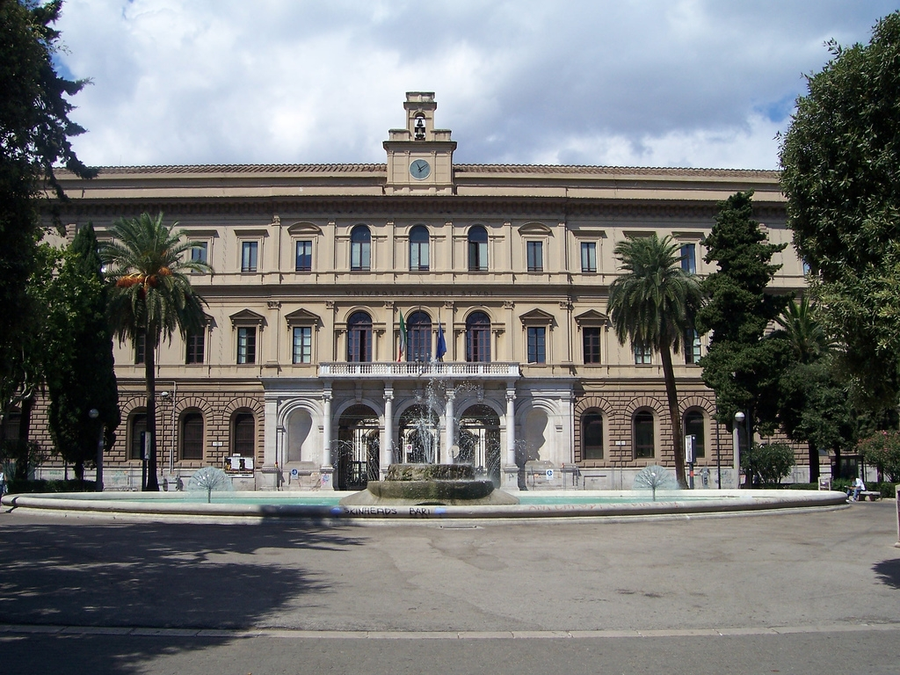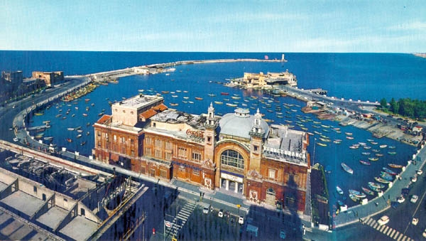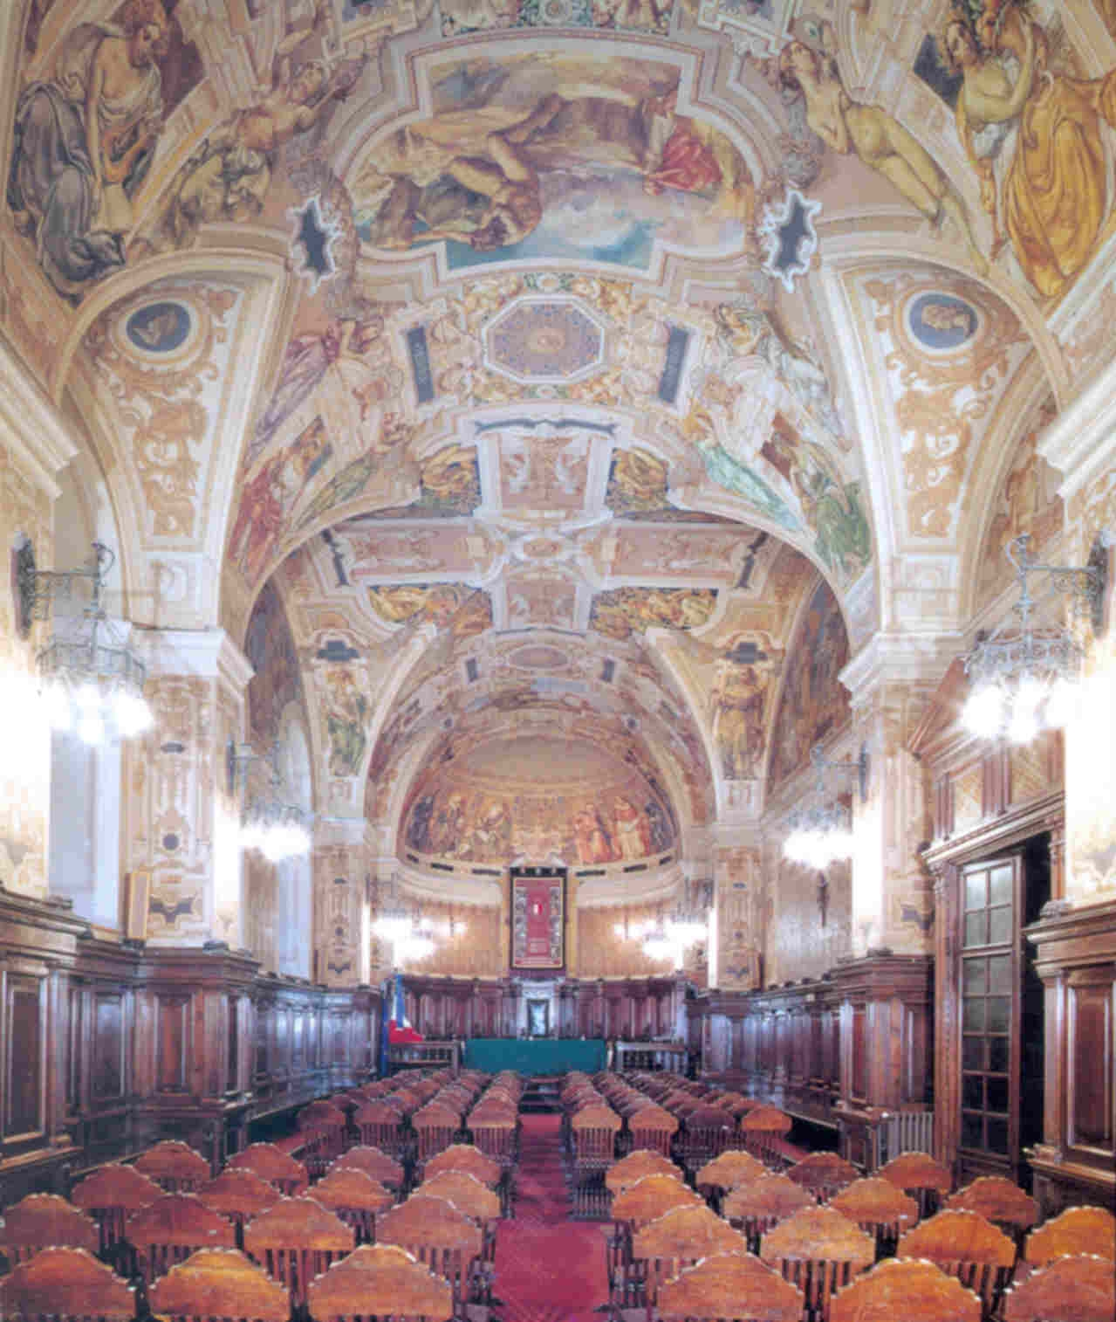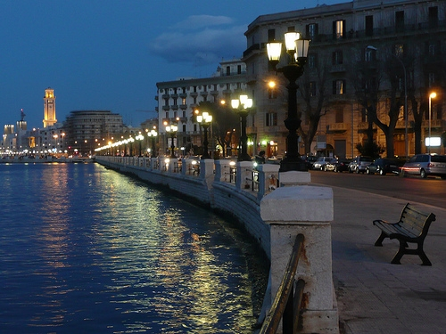

## ****Reaching Bari by plane****



The Airport of Bari is the [Palese Airport](http://www.aeroportidipuglia.it/default.asp?idlingua=1&idContenuto=25), dedicated to Karol Wojtyla since 2005. The airport is one of the most important airports of the region. Many destinations are reachable thanks to some partnerships with the major airlines (either low-cost or flag carrier).

## ****Reaching Bari by train****



Like all the big cities of Apulia, Bari is connected by railway with all Italian city centres.The major Italian railway public company is [TRENITALIA](http://www.trenitalia.com/). ([www.trenitalia.it](http://www.trenitalia.it))

## ****Reaching Bari by car****



Reaching Bari by car is faster by using the [motorways](http://www.autostrade.it/): the A14 starts at Bologna and touches Foggia, Bari, Taranto and the A16 that connects Bari and Naples. Italian motorways are mostly administrated by ANAS Concessionary Companies and are usually subjected to payment of the toll.

## ****Reaching Bari by Bus****



Buses allow you to reach Bari from every part of Italy. There are many Bus Companies in Bari with daily departures heading to Milan, Bologna, Rome, Naples, Pisa, Siena, Palermo e Catania.

The major companies are: Asv (Linea Urbana Bitonto);  Baltour ciarrocchi; Chiruzzi; Conca michele autoservizi extraurbani; Elios autoservizi; Fal; Ferrovie del Gargano; Ferrovie del Sud; Ferrotramviaria; Interbus; Marino michele; Marozzi; Miccolis; Saps; Stp; Sita puglia.

***Conference Hotels***:

**Hotel Victor** **** , Via Domenico Nicolai, 71, 70122 – Bari  
Tel. +39 080 5216600; Fax +39 080 5212601

Reception/Booking: [info@hotelvictorbari.it](mailto:info@hotelvictorbari.it)

*72,00 euro (double room) 55,00 (single room)*

**Hotel Moderno** *** ,Via Crisanzio, 60 - 70122 - BARI   
Tel. +39-080-5.213.313 ; Fax +39-080-5.214.718

*75,00 euro (double room) , 55,00 euro (single room)*

[hotel@modernobari.com](mailto:hotel@modernobari.com)

**Best Western Executive Hotel** *** ,Corso Vittorio Emanuele 201 - 70122 Bari   
Telefono: **+39 080 5216810** Fax: **+39 080 5225222** <http://www.bestwestern.com/reservations/wwtelephonenumbers.asp>Email: [executive.ba@bestwestern.it](mailto:executive.ba@bestwestern.it);

*90,00 euro (double room), 68,00 (single room)*

**Hotel Boston** *\*\*\*,* Via Piccinni, 155 , 70122, Bari

Tel. +39 080 5216633 | Fax +39 080 5246802, [info@bostonbari.it](mailto:info@bostonbari.it);

*85,00 euro (double room), 65,00 euro (single room)*

**B&B Residenza Sveva** ***, P.zza Luigi di Savoia, 24 – 70121, Bari

Tel: 0039 335 780 96 81; Fax: 0039 080 969 22 00 [info@residenzasveva.it](mailto:info@residenzasveva.it); *40,00 euro (single room), 55,00 euro (double room)*

**B&B Dolcirisvegli ***,** Via De Nicolò 7, 70121 Bari**;** +39 346 680 5168; +39 329 040 9137; <http://www.baribedandbreakfast.com/b-b-dolci-risvegli/> 40,00 euro (single room), 60,00 euro (double room)

***Scientific Committee***

Nicoleta Corbu – National School of Political Studies and Public Administration, Bucharest, Romania

Giuliana Garzone – Department of Modern Languages and Cultures, State University of Milan, Italy

Adrian Lesenciuc – “Henri Coanda” Air Force Academy, Brasov, Romania

Lachlan Mackenzie – Honorary member of the University of Amsterdam; Instituto de Linguística Teórica e Computacional, Lisbon, Portugal

John McKeown – Mefis International School, Istanbul, Turkey

Esther Pascual Olivé – Department of Communication Studies, Groningen University, The Netherlands

Dana Popescu-Jourdy – Institut de Communication, Université “Lumiere” Lyon 2, France

Maria de Sao Jose Corte-Real – Faculdade de Ciencias Sociais e Humanas, Universidade Nova, Lisbon, Portugal

Helen Spencer-Oatey – Centre for Applied Linguistics, Warwick University, the U.K.

Anna Triandafyllidou – European University Institute, Florence, Italy

Maria Zaleska – University of Warsaw, Poland

***Organising Committee***

Michele Baldassarre – Researcher of Experimental Pedagogy, University of Bari, Italy

Linda Cassibba – Director Deparment of Educational Sciences, Psychology, Communication, University of Bari, Italy

Luca Gallo – Full Professor of Comparative Education, Director of the Laboratory of Intercultural Education , University of Bari, Italy

Alberto Fornasari – Researcher of Experimental Pedagogy, University of Bari, Italy

Beatrice Ligorio – Associate Professor of Educational Psychology ,University of Bari, Italy

Luisa Santelli Beccegato – (Former) Full Professor of Experimental Pedagogy, University of Bari, Italy

Paola Zaccaria – President of the Degree Course in Communication Sciences, Full Professor of Anglo-American Literature , University of Bari, Italy

***Contact***

Please check periodically the Conference website or send inquiries to [alberto.fornasari@uniba.it](mailto:alberto.fornasari@uniba.it)